For Immediate Release
November 4, 2021

The 101030 Campaign Elevates and Celebrates
the Journey of the Family Caregiver
Campaign created to support the unofficially ranked #1 Job in the world
in support of National Family Caregivers Month

DENVER, CO – In the past 18 months, the role of family caregiving has ignited a worldwide conversation and positioned itself as the “unofficial #1 unpaid job in the world.” This year, The 101030 Campaign, a month-long celebration of the family caregiver, will reignite the conversation by honoring the journey of these often-unrecognized community heroes. The Campaign runs thru November 30, 2021, in conjunction with National Family Caregivers Month.

Acknowledged as the first-ever 30-day gifting and celebratory event of its kind – The 101030 Campaign supports the modern family caregiver by building their strength and providing practical tools for conscious caregiving and self-care. This year, the Campaign highlights the 24-hour role of the family caregiver, focusing on more direct action supporting their day-to-day role.

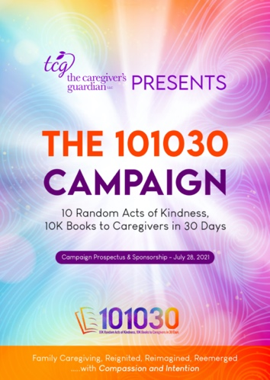
“No matter who you are, where you are, or what you do, everyone will be affected by caregiving at some point in their lives,” said Nadine Roberts Cornish, Founder of The Caregiver’s Guardian and the visionary behind The 101030 Campaign. “COVID-19 catapulted the role of caregiver front and center of the national conversation on healthcare. Now, more than ever, the need for advocacy and celebration of these silent angels is imperative.”

There are over 53 million Americans who are unpaid caregivers to family, friends, and neighbors. The value of the services family caregivers provide for "free" when caring for a loved one is estimated to be $470 billion a year. That is almost twice as much as is spent on homecare and nursing home services combined (est. $158 billion). Since COVID-19, the numbers have risen substantially.

The 101030 Campaign will take place in communities throughout the country, offering random acts of kindness, professional support and training sessions, and gifts for personal wellness and self-care to help family caregivers sustain themselves during the caregiving journey. This year, the Campaign’s offerings include:

-more-
- The TCG Caregiver Dance Party: Gives caregivers a break from caregiving and energizes their spirit. Connect and dance with other caregivers in the comfort of your own home. (Nov. 5, 6pm MST)
- Compassion In My Cup: A Coffee, Tea & Conversation w/a Caregiver Series: An exclusive in-person and virtual event where family caregivers get to listen and be heard in a safe space with other caregivers. (Every Tuesday in November at 1pm MST)
- Self-Care Spa Packages: Virtual spa facial treatments and packages and parties, mini caregiver pampering packs, and more, hosted by Five Wellbeing Spa.
- 10K Literary Acts of Kindness Gifts: Inspirational books by caregiving experts. Titles include Tears in My Gumbo, Prayers in My Gumbo, and Family Strong-7 Gifts for a Family Legacy.
- Meal Deliveries: Meal preparation and deliveries to family caregivers, hosted by Gourmet Away.
- Random Acts of Kindness: In-kind gifts of support; call a caregiver to check on them, connect with them via a Zoom call, buy them dinner, offer respite to give them a break from daily responsibilities, etc.

“During this transition to our “new normal,” the goal of the 101030 Campaign is to reignite and reinvest in the role of the family caregiver,” Roberts Cornish said. “By creating customized strategies that offer nurturing guidance, value-based training, and self-care and wellness programs, we can improve the lives of family caregivers at home and in the workplace. Thus, allowing families and their caregivers to reemerge resiliently.”

The 101030 Campaign welcomes the support of community based-organizations, corporations, foundations, healthcare organizations, churches, and individuals who can take part in supporting caregivers thru random acts of kindness and with the distribution of gifts and books. For more information visit, tcgcares.com/the-101030-campaign.

Media Contact (s):

Gerri Gomez Howard
gerri@gomezhowardgroup.com
303.748.3933 Mobile
Lori Goodwine
lori@lgprconsulting.com
702.583.4990 Mobile

About The 101030 Campaign
The 101030 Campaign is an annual event created to honor and celebrate the role of the family caregiver. Mission-driven, the 101030 Campaign is focused on helping the family caregiver in multiple areas including, achieving self-care goals, long-term planning, and incorporating the 5-steps of conscience caregiving into their daily practices. Established in 2020, The 101030 Campaign is a campaign of The Caregiver’s Guardian. For more information visit, tcgcares.com/the-101030-campaign.

About The Caregiver’s Guardian
The Caregiver’s Guardian (TCG) is a Denver, Colorado-based consulting service that supports, encourages, and advocates for the family caregiver. TCG was founded by Nadine Roberts Cornish, Author, caregiver coach, healthcare consultant, and renowned public speaker for more than 20 years. TCG provides training and speaking engagements that motivate and inform caregivers and professionals on the importance of being an active participant in the caregiving process. At the same time, incorporating the critical essentials to caregiving success for the entire family. For more information visit, tcgcares.com.

###

